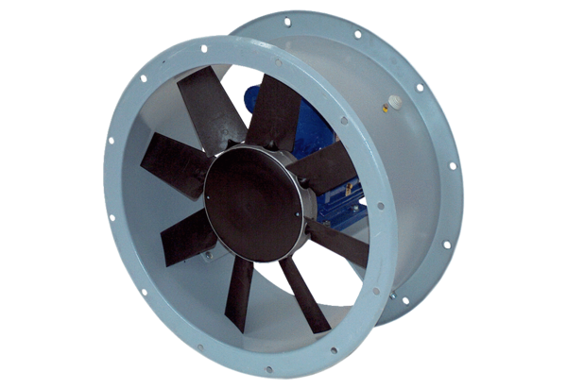Axial duct fan DAR 71/8 0,37Packing unit: 1 pieceRange: C
Article number: 0073.0136Manufacturer: MAICO

