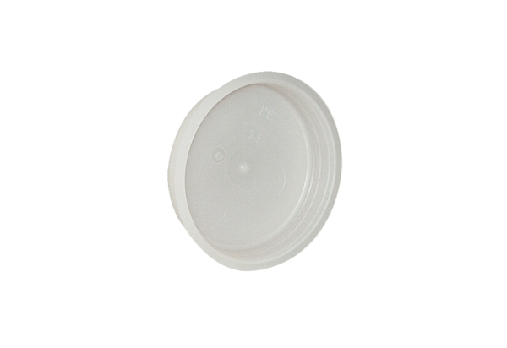End plug MF-FST75Packing unit: 10 piecesRange: K
Article number: 0059.0977Manufacturer: MAICO

