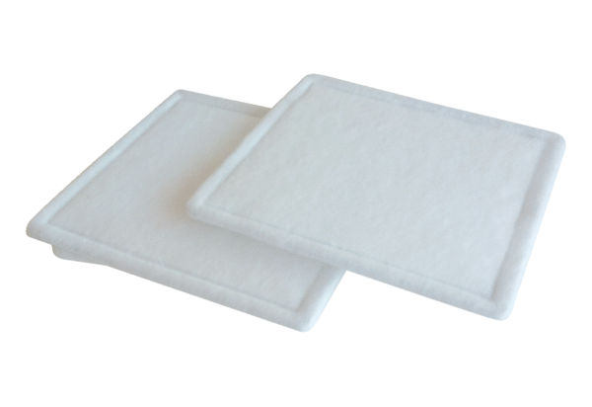Air filter, replacement RF 16-4Packing unit: 2 piecesRange: C
Article number: 0093.0071Manufacturer: MAICO

