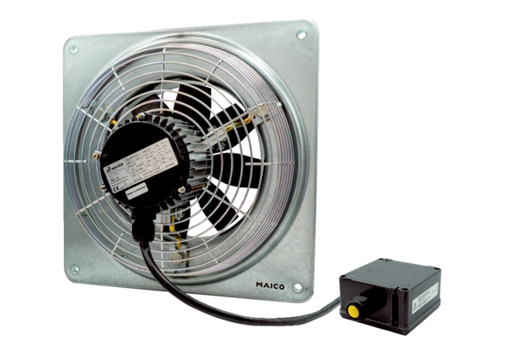Axial wall fan DZQ 25/2 B Ex tPacking unit: 1 pieceRange: C
Article number: 0083.0203Manufacturer: MAICO

