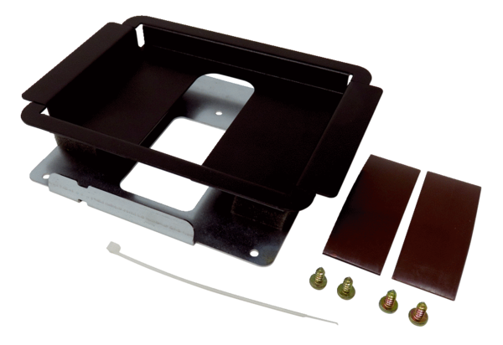Bracket for room air control HB WS 75Range: K
Article number: E093.1620.0000Manufacturer: MAICO

