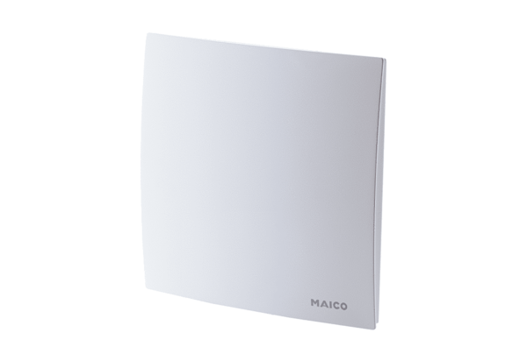Cover ER-AKPacking unit: 1 pieceRange: B
Article number: 0084.0362Manufacturer: MAICO

