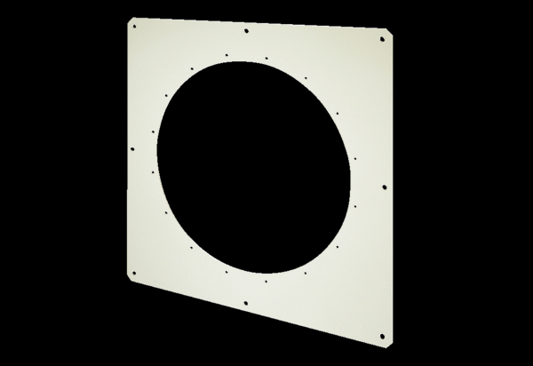Square wall plate QW 100Packing unit: 1 pieceRange: C
Article number: 0053.0016Manufacturer: MAICO

