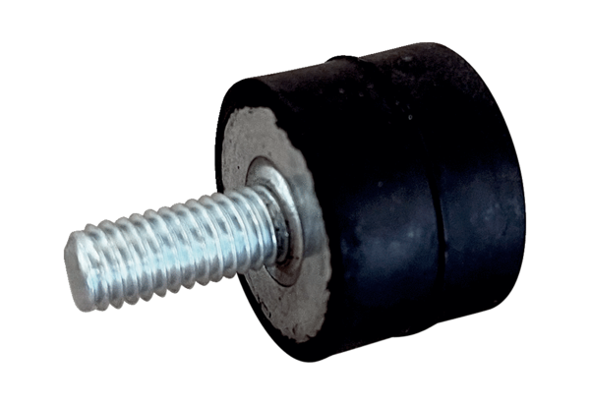Vibration damper GPI 131-220Packing unit: 1 pieceRange: C
Article number: 0073.0277Manufacturer: MAICO

