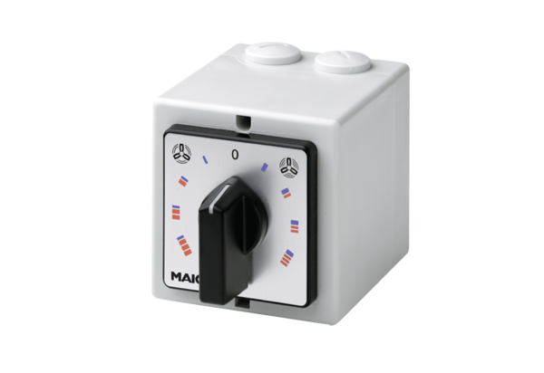HP 2Packing unit: 1 pieceRange: C
Article number: 0157.0465Manufacturer: MAICO

