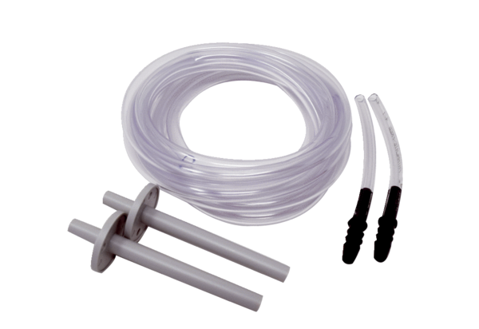Installation kit DDEx 500 IKPacking unit: 1 pieceRange: C
Article number: 0157.0304Manufacturer: MAICO

