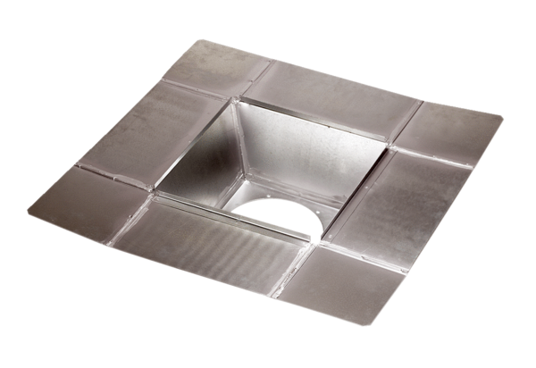Intermediate socket SZ 63Packing unit: 1 pieceRange:
Article number: 0092.0294ALTManufacturer: MAICO

