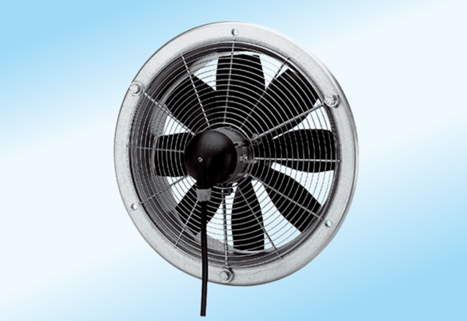Axial wall fan DZS 40/4 A-ExPacking unit: 1 pieceRange: C
Article number: 0094.0112Manufacturer: MAICO

