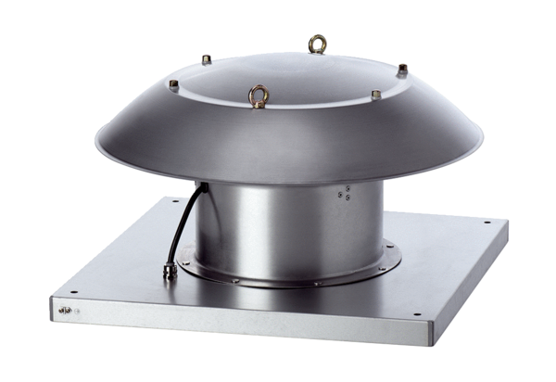Axial roof fan DZD 35/6 B Ex ePacking unit: 1 pieceRange: C
Article number: 0087.0801Manufacturer: MAICO

