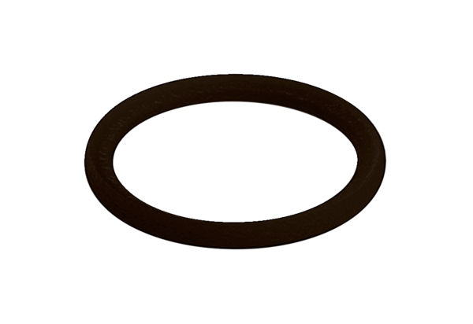Sealing ring MA-D75Packing unit: 10 piecesRange: K
Article number: 0175.0334Manufacturer: MAICO

