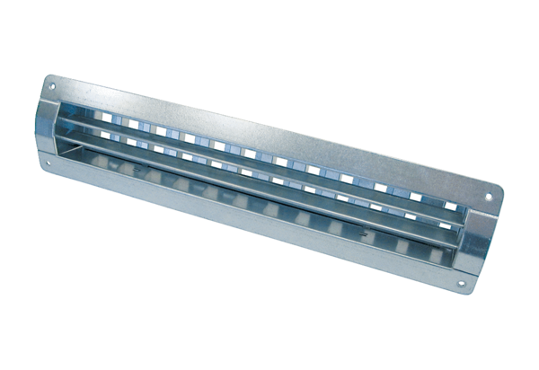Internal grille LGR 42/12Packing unit: 1 pieceRange: C
Article number: 0151.0360Manufacturer: MAICO

