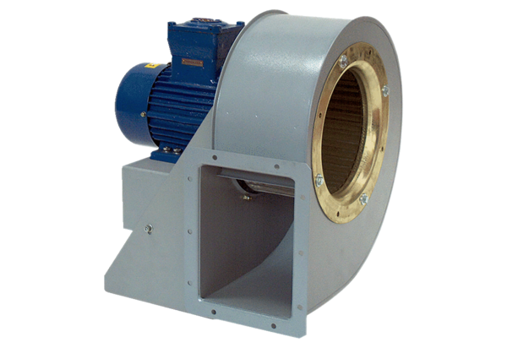Centrifugal blower GRM HD 40/8 ExPacking unit: 1 pieceRange: C
Article number: 0073.0416Manufacturer: MAICO

