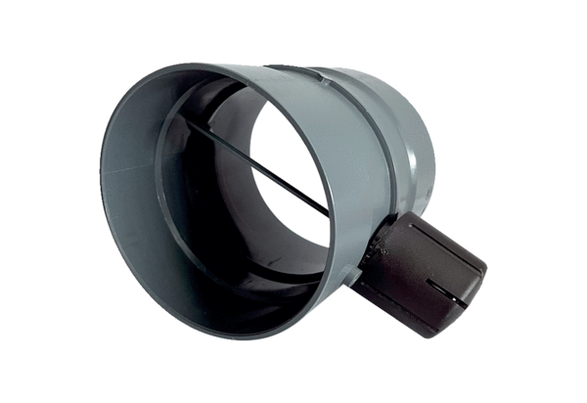Manual throttle valve MDKI 20Packing unit: 1 pieceRange: C
Article number: 0073.0480Manufacturer: MAICO

