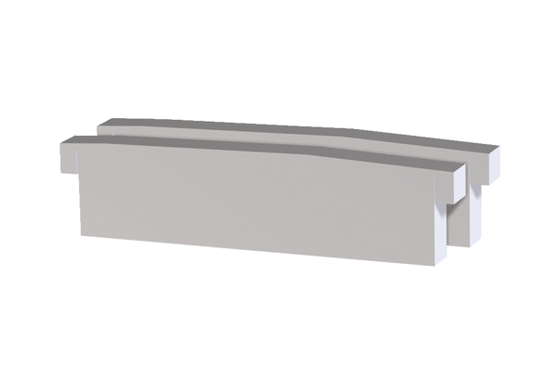Air filter, replacement PPB 30 G3Packing unit: 2 piecesRange: K
Article number: 0093.1502Manufacturer: MAICO

