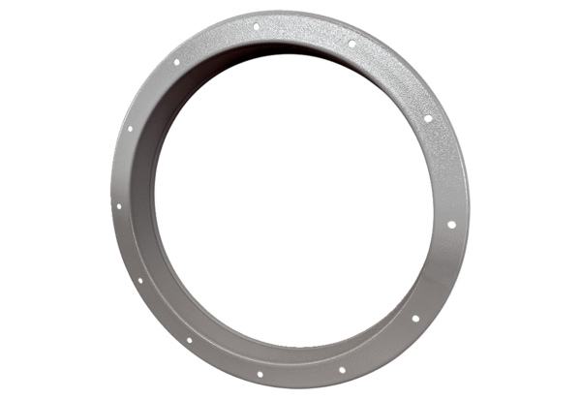Counter socket GSI 63Packing unit: 1 pieceRange: C
Article number: 0073.0266Manufacturer: MAICO

