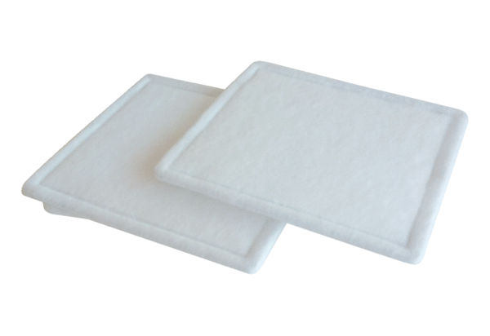Air filter, replacement RF 10-4Packing unit: 2 piecesRange: C
Article number: 0093.0059Manufacturer: MAICO

