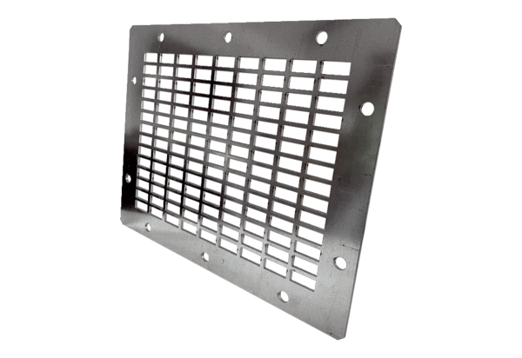Air outlet grille SGAI GR 35Packing unit: 1 pieceRange: C
Article number: 0073.0430Manufacturer: MAICO

