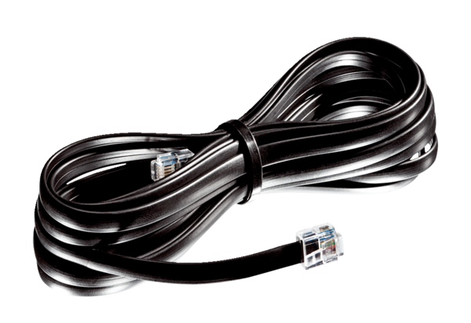Connecting duct WRG 35-TAK 5Packing unit: 1 pieceRange: K
Article number: 0092.0502Manufacturer: MAICO

