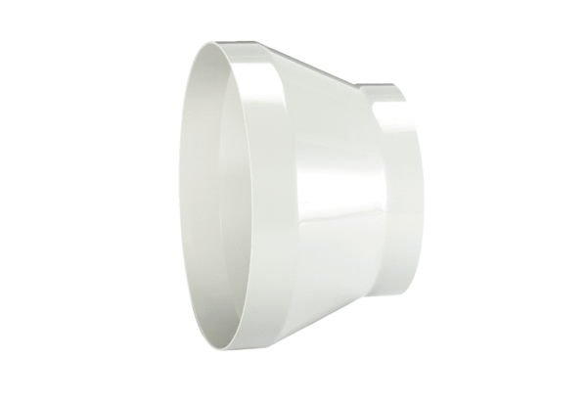Reducer REM 28/20Packing unit: 1 pieceRange: C
Article number: 0059.0639Manufacturer: MAICO

