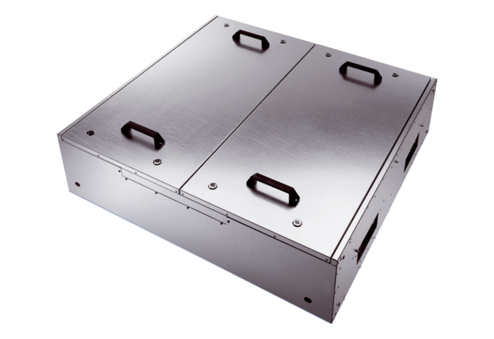Sound-insulated ventilation box KFD 9030Packing unit: 1 pieceRange: K
Article number: 0080.0964Manufacturer: MAICO

