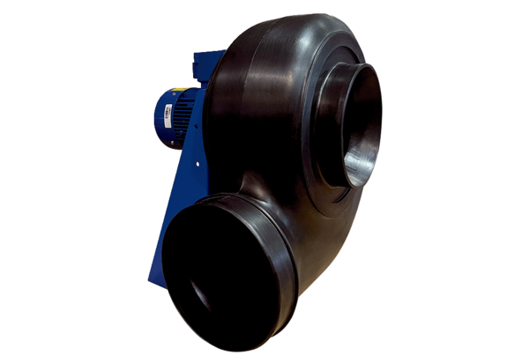Centrifugal blower GRK R 20/2 D ExPacking unit: 1 pieceRange: C
Article number: 0073.0441Manufacturer: MAICO

