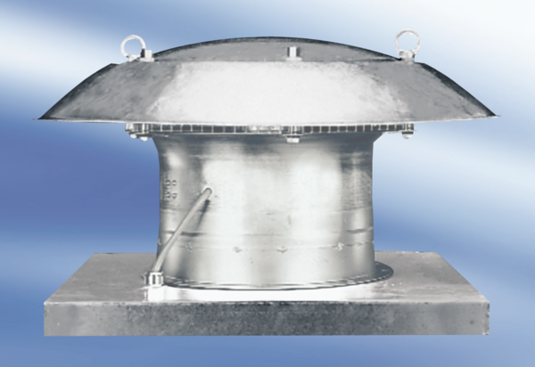Axial roof fan DZD 25/4 A-ExPacking unit: 1 pieceRange: C
Article number: 0087.0760Manufacturer: MAICO

