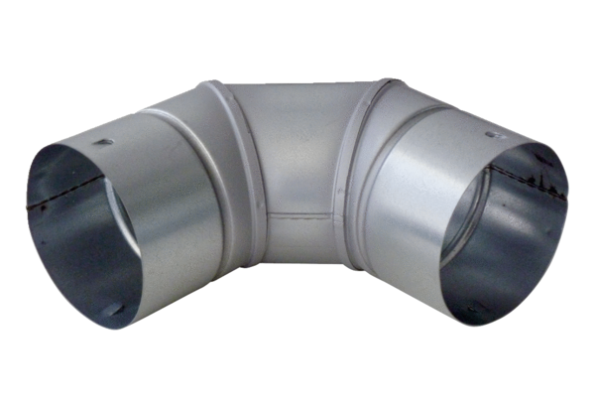90° sheet metal elbow MF-B63Packing unit: 1 pieceRange: K
Article number: 0018.0068Manufacturer: MAICO

