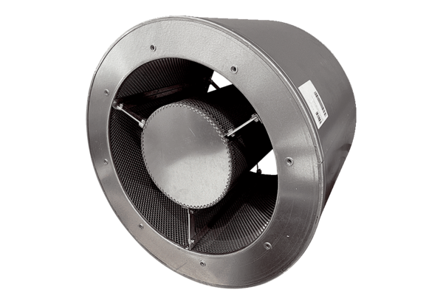Tubular sound absorber RSKI 90/1000Packing unit: 1 pieceRange: C
Article number: 0073.0118Manufacturer: MAICO

