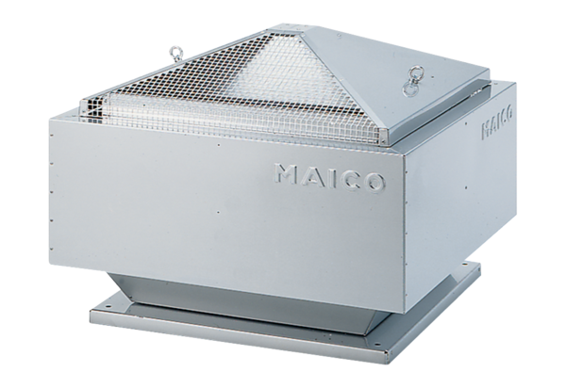Centrifugal roof fan DRD 35/4 BPacking unit: 1 pieceRange: C
Article number: 0087.0106Manufacturer: MAICO

