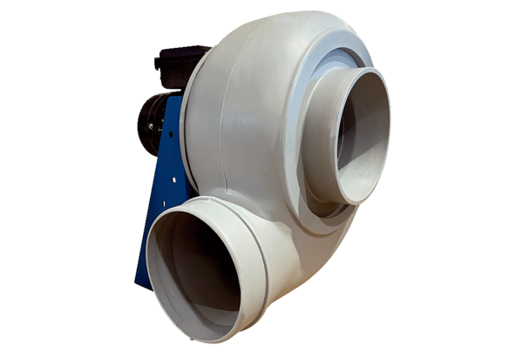Centrifugal blower GRK R 31/6 DPacking unit: 1 pieceRange: C
Article number: 0073.0520Manufacturer: MAICO

