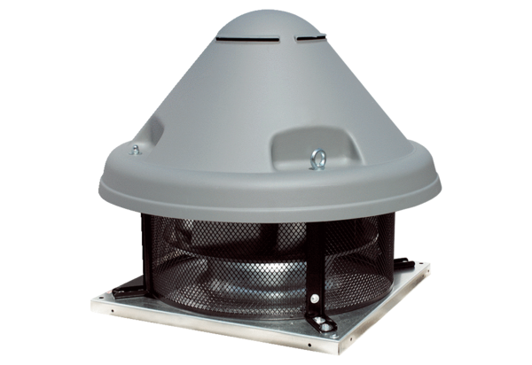Centrifugal roof fan DRD H 45/4 ExPacking unit: 1 pieceRange: C
Article number: 0073.0538Manufacturer: MAICO

