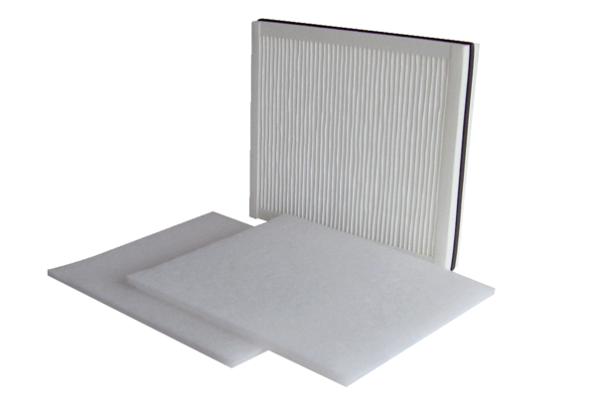Air filter, replacement WSF 600Packing unit: 1 set (3 pieces)Range: K
Article number: 0093.0689Manufacturer: MAICO

