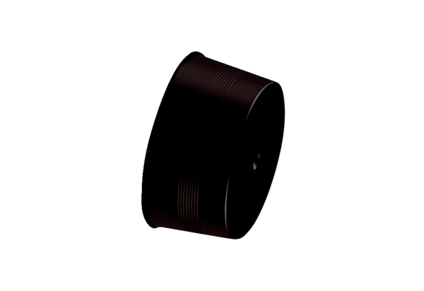Sealing cover MA-VD63<data>
<p class="FT">Packing unit:</p>
</data>
10 pieces<data>
<p class="FT">Range:</p>
</data>
K
<data>
<p class="FT">Article number:</p>
</data>
0059.2137<data>
<p class="FT">Manufacturer:</p>
</data>
MAICO

