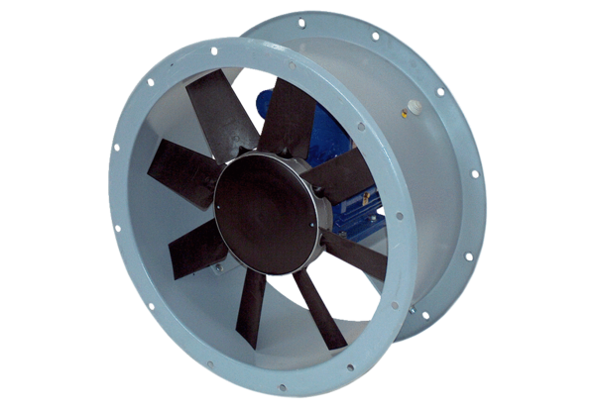Axial duct fan DAR 100/4 15Packing unit: 1 pieceRange: C
Article number: 0073.0171Manufacturer: MAICO

