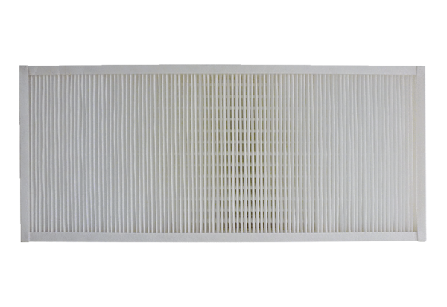Air filter, replacement KFF 9040-5Packing unit: 1 pieceRange: K
Article number: 0093.1217Manufacturer: MAICO

