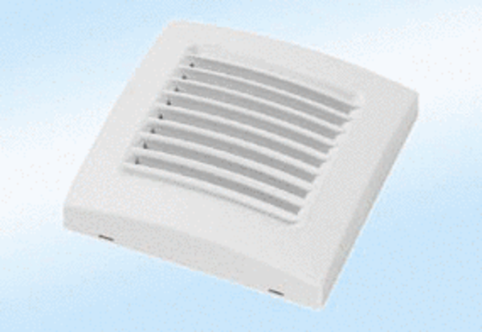Coloured cover A 100 calypsoPacking unit: 1 pieceRange: A
Article number: 0092.0365Manufacturer: MAICO

