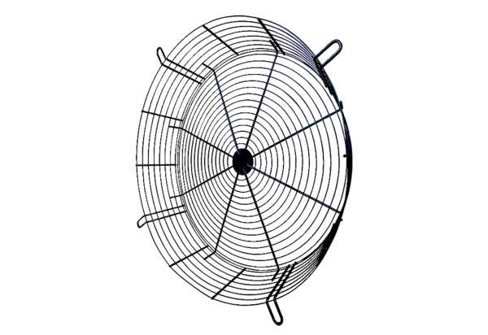Protection against accidental contact SGCI 90Packing unit: 1 pieceRange: C
Article number: 0073.0096Manufacturer: MAICO

