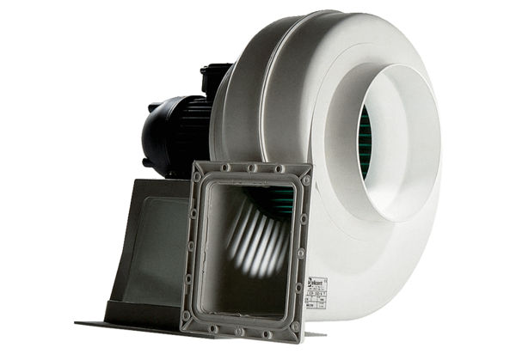Centrifugal blower GRK 12/4 DPacking unit: 1 pieceRange: C
Article number: 0073.0304Manufacturer: MAICO

