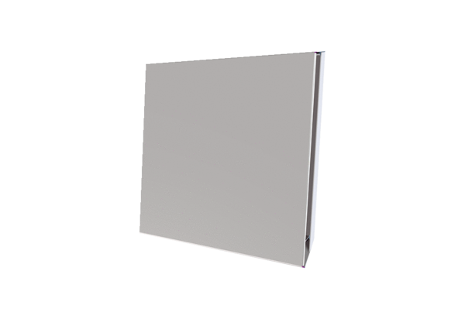External cover PPB 30 AWPacking unit: 1 pieceRange: K
Article number: 0093.1500Manufacturer: MAICO

