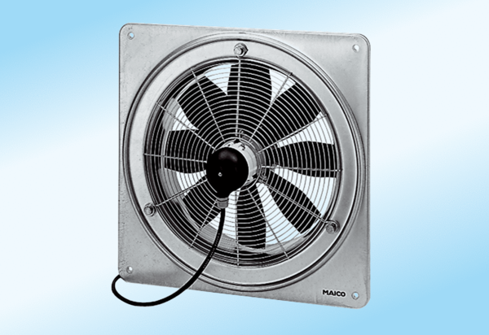Axial wall fan DZQ 40/6 A-ExPacking unit: 1 pieceRange: C
Article number: 0083.0775Manufacturer: MAICO

