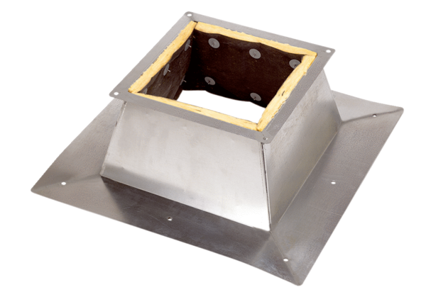Roof socket for flat roofs SO 63Packing unit: 1 pieceRange: C
Article number: 0093.0359Manufacturer: MAICO

