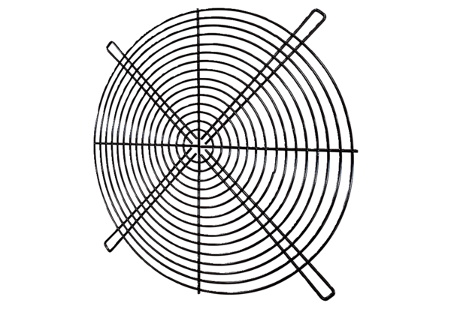Protective grille SGRI 35Packing unit: 1 pieceRange: C
Article number: 0073.0422Manufacturer: MAICO

