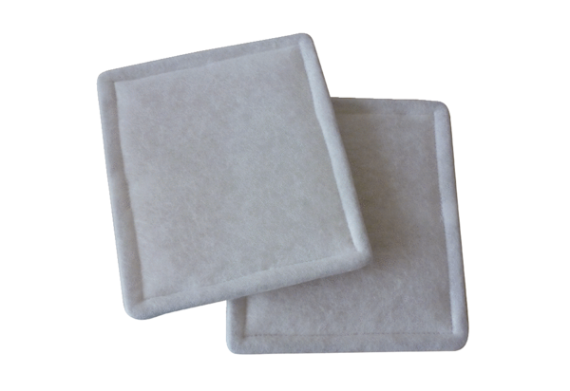Air filter, replacement RF 25Packing unit: 2 piecesRange: C
Article number: 0093.0694Manufacturer: MAICO

