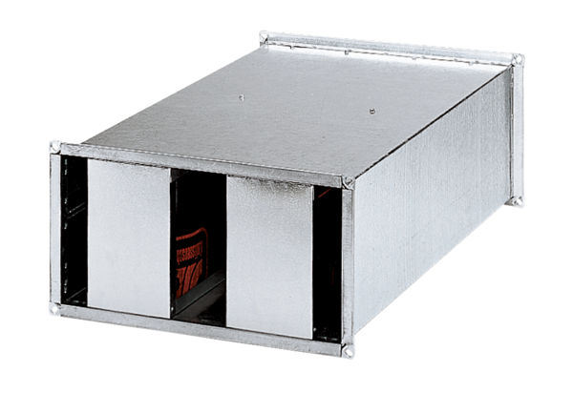Channel sound absorber KSP 94/28Packing unit: 1 pieceRange: D
Article number: 0092.0505Manufacturer: MAICO

