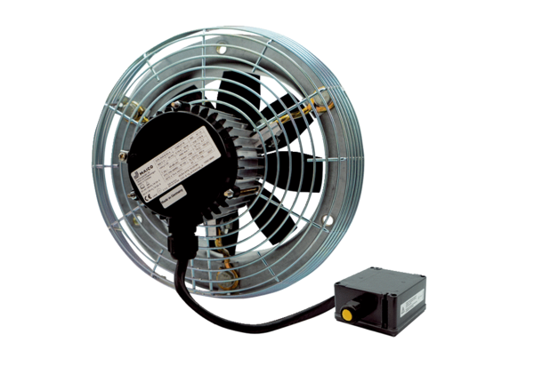Axial wall fan DZS 40/4 B Ex ePacking unit: 1 pieceRange: C
Article number: 0094.0127Manufacturer: MAICO

