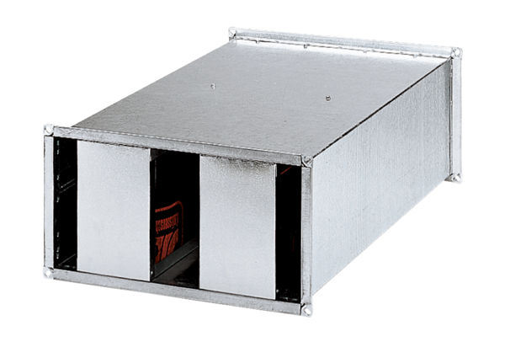Channel sound absorber KSP 25/27Packing unit: 1 pieceRange: D
Article number: 0092.0331Manufacturer: MAICO

