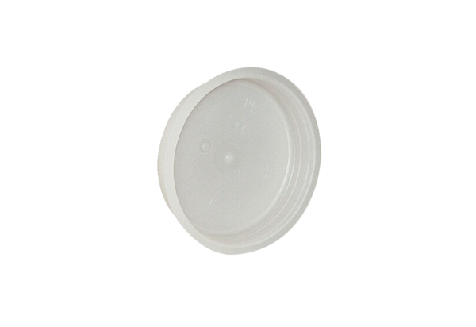End plug MF-FST63Packing unit: 10 piecesRange: K
Article number: 0059.0976Manufacturer: MAICO

