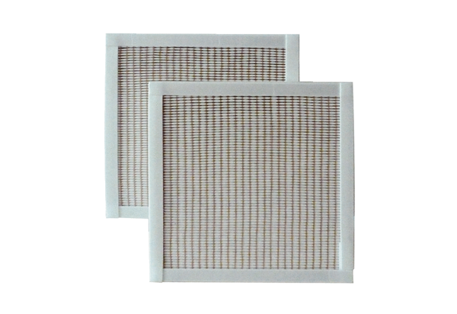Air filter, replacement RF 25-5Packing unit: 2 piecesRange: C
Article number: 0093.0877Manufacturer: MAICO

