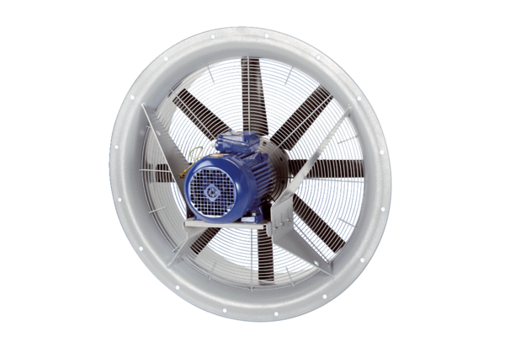Axial fan DAS 100/4Packing unit: 1 pieceRange: C
Article number: 0083.0862Manufacturer: MAICO

