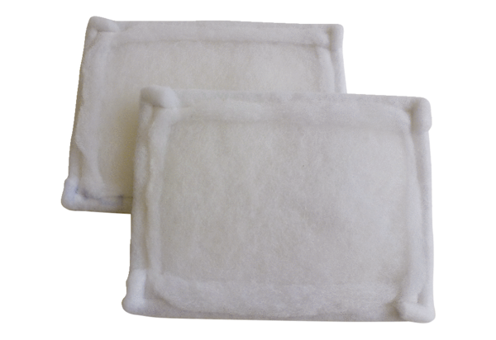Air filter, replacement FE 25-1Packing unit: 2 piecesRange: C
Article number: 0093.1226Manufacturer: MAICO

